Names ________________________ ________________________
________________________ ________________________

Make 4 s’mores, one for each group member. Layer 1 cracker, ½ chocolate bar, 1 marshmallow, and 1 cracker.
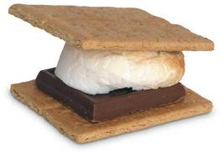
Your resources
- 2 marshmallows
- 1 chocolate bar
- 8 graham crackers

- Can you make all 4 s’mores as instructed?

____________________________________________________

- Which resources are scarce? (You do not have enough)

________________________ ________________________

3. What are your choices?

____________________________________________________

____________________________________________________

____________________________________________________

