Name:_____________________________________
Exit Ticket

This man is cutting a tree. What is the natural, human, and capital resource?
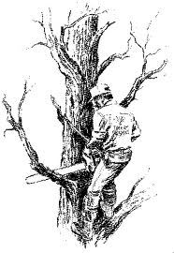
Natural resource _____________________________________

Humans resource ____________________________________

Capital resource _____________________________________

